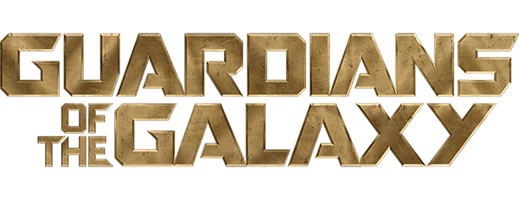

Sprint 122 Summary
Sep 23, 2026 - Oct 6, 2026

Sprint Highlights
A major effort was dedicated to Anomalies Center, delivering additional backend API capabilities, configurable initial data loading, and UI/API/e2e automation coverage. The team also resolved critical issues involving duplicate anomalies and missing group information in API responses. In parallel, the Anodot significance score issue was fixed, and functional testing of the new anomaly detection service continued.
In VoC, improvements included survey targeting regex support and Email Digest subscription cleanup. The team also addressed a customer-reported Session Replay issue for Honeywell. Additional fixes were delivered across Alerts and WebUI Tools, while regression testing for the Jetty upgrade was completed.
Several items remained incomplete due to urgent Anomalies Center stabilization work, legacy implementation issues, and unexpected technical complexity. These included sorting and search functionality, historical anomaly visualization, and remaining backend validation for an Anomalies Center hotfix. An Alerts data-population issue also required deeper investigation after the Code Agent solution proved insufficient.
Overall, Sprint 122 prioritized post-MVP stabilization and release quality, addressing critical defects while continuing Anomalies Center development. The urgent fixes and additional validation effort affected planned feature delivery, but helped strengthen the reliability of the new functionality.

Sprint Delivery
Velocity: ~41
Sprint Accuracy: ~73%

Delivered
Summary | Comment
GNG-55609
[Sprint 122][Tech] Planning, Test Case Analysis and Fix Automation
GNG-55570
[Anomalies Center][BE] Add ability to configure the count of the items to be shown on the first page load
GNG-55550
[glare][Tech] Functionality test for new anomaly detection service - Part 2
GNG-55179
[Anomalies Center][QA] UI/API/e2e automation testing
GNG-55178
[Anomalies Center][BE] API Endpoints - Part 2
GNG-54841
[Tech] Jetty upgrade - regression testing (Guardians)
GNG-54279
[VOC] Triggers - Targeting Regex
GNG-53134
[Alerts] Fix Dimension entity
GNG-51609
[Anodot] Significance Score should not be 0 when widget data is missing
GNG-47839
[VOC][Email digest][BE] Subscriptions cleanup when the survey is deleted (hard delete)
GNG-55241
[VoC/VoS] Honeywell - Session Replay from VoC Breaks When Refreshed or Accessed by Direct Link
GNG-54927
[WebUI Tools][Data Export] KAFKA security SASL JAAS config field entire value is masked and cannot be retrieved
GNG-55940
[Anomaly Center] The same anomaly is displayed multiple times in the list
GNG-55802
[Anomalies Center] Not all objects include a 'group' in the response from the '/feed' endpoint

Not completed
Summary | Comment
GNG-55939  [Anomaly Center] Page is not displayed when navigating to it | FE HF was merged to 7.3.274  BE fix is provided, awaits for testing for 7.3.278.
GNG-55938  [Anomaly Center] Incorrect display of historical anomaly on the chart | Old development issue root cause
GNG-55225  [Anomalies Center] Add Sorting for Anomalies List | Development in progress. Delayed due to other urgent issues in Anomalies Center
GNG-55219
[Anomalies Center] Add Search filter for Anomalies List
GNG-54684  [Alerts] Threshold-based Board - Based Report with Sessions scope widget not populating any Data, although the source Report returns data correctly | The Code Agent solution did not resolve the issue. Needs deeper investigation
Sprint Reports
Velocity
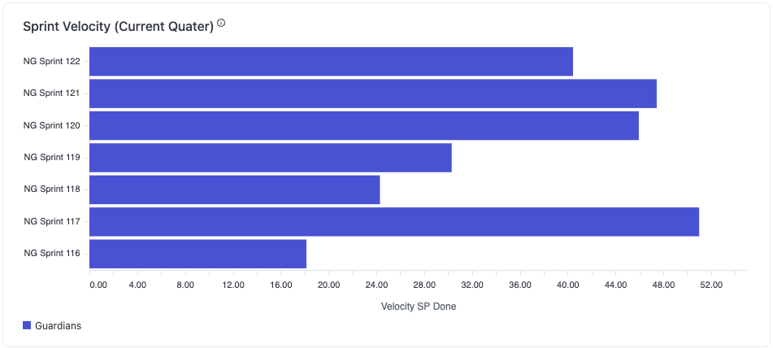

Escalated Customer ticket backlog

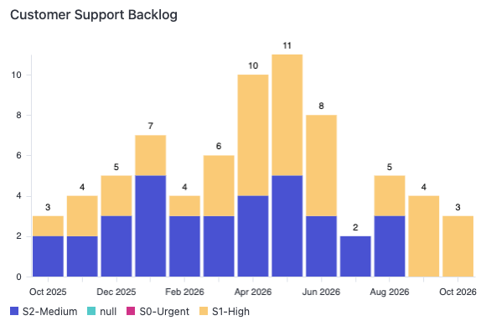

Bugs backlog
